

IQ32 SDR Transceiver

Operations Manual

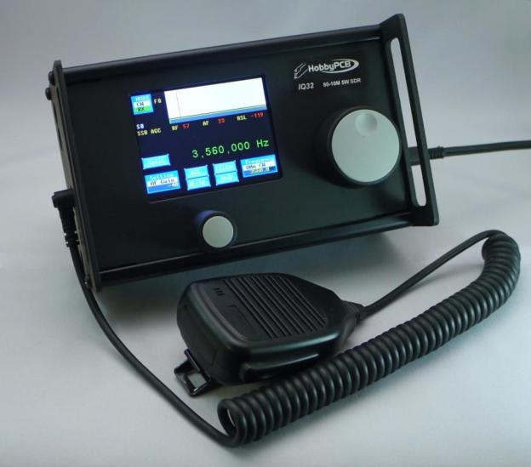

**Table of Contents**

Basic Navigation 4

Mode Selection 5

Settings Screens 8

Main Settings 9

Advanced Settings 10

Keyboard Fn Settings 12

Screen Fn Settings 22

<Tags> (PSK Macro) Settings 30

Bandpass Filter Settings 35

Frequency Manager Screen 37

Receive Filter Settings 41

CW Operation 42

SSB Operation 47

PSK Operation 50

AGC Modes Explained 58

Mode 0 58

Mode 1 58

Mode 2 58

Mode 3 58

PSK Cheat Sheet 59

F1: Call CQ 59

F2: Send Your Name and QTH 59

F3: Send your Rig information 59

F4: Send your Antenna information 59

F5: Confirm Called Station Name and Callsign, and send Back to You (BTU) 59

F6: Send Thank You and Best Wishes (73's) 59

F7: (Changes to USB mode) 59

F8: (Changes to LSB mode) 59

F9: (Changes to CW mode) 59

F10: Toggles Transmitter Between Receive and Transmit Mode 59

F11: Clear Transmit Buffer 59

F12: _________________________________________________________________ 59

Radio Setup 60

Appendix – Tags, Functions, Buttons, and Keyboard. 61

Tags 61

Functions 62

Default On-Screen Button Functions 62

SSB Operational Screens Buttons 62

CW Operational Screens Buttons 63

PSK Operational Screens Buttons ** 63

Keyboard Function Keys 63

# Basic Navigation

Thank you for purchasing a HobbyPCB IQ32 transceiver, connect a suitable antenna or dummy load and a power supply. Remember, you are responsible for the radio, and you must ensure that any emissions are on a proper frequency (one for which you are properly licensed and allowed to transmit).

Turn on the power, and you should see the splash screen as depicted below in Figure 1. It announces the version of the software you are running. This picture shows the current version at the time of preparation of this document. We expect the software will continue to evolve, and it is always possible (actually, probable) that there has been an update to the firmware that snuck out (sneaked out?) into the open in between updates to the documentation.

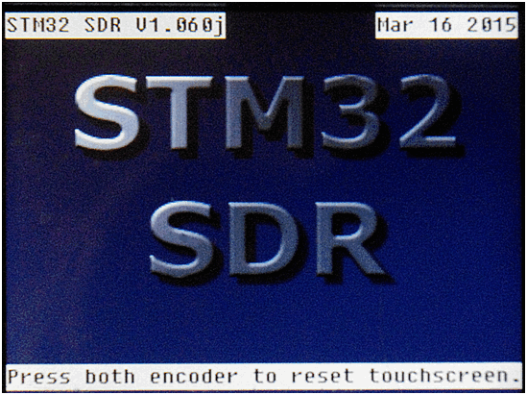

Figure 1: Sign-On (“Splash”) Screen

You can go to <http://www.hobbypcb.com/iq32> to check for firmware updates

After a few seconds, you should see the screen shown below (Figure 4). It’s the home screen.

From here you can start your journey, and at each subsequent power-up, you will be returned here after the “splash screen” is briefly displayed.

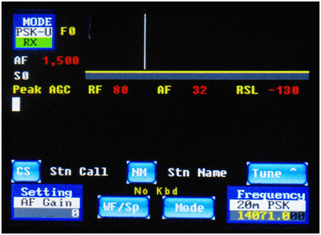

Figure 4: Home Screen (PSK Operation)

The software has multiple screens that are accessed by pressing the appropriate place on the touchscreen. These icons are multifunction. The top line indicates the name of the icon, what secondary screen or function it selects, what option is currently selected and the value of the option. These are all in a touch sensitive area on the screen.

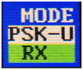

Figure 5: Mode Icon

## Mode Selection

So, for example, Figure 5 (above) is called the Mode icon or Mode widget. Pressing it will bring you to the mode selection screen. The current mode is PSK-U (PSK in USB) and we are currently in Receive (RX). If you touch the Mode icon (upper left corner of the screen) you will switch to the Mode selection screen (Figure 6, depicted below).

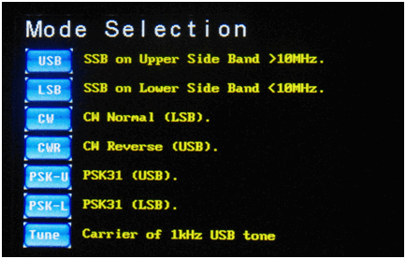

Figure 6: Mode Selection Screen

On the mode selection screen, you can select the operating mode you desire, by touching the appropriate on-screen button, and it will switch to that mode and the mode’s operating screen. If you selected the wrong one, you just have to hit the mode button (Figure 5) on that screen to return to the mode selection screen, and re-select the desired one. Later in the document I will give you more details on the selections but they should be pretty self-explanatory already.

One new button on this screen is the “Tune” button which sends out a 1 Khz carrier so you can set the power level or tune your transmitter to your antenna, when the IQ32 is connected to the HobbyPCB Hardrock-50 power amplifier

Press the USB icon (Figure 7) and go to the USB Screen (Figure 8).



Figure 7: USB Icon

Once on the USB screen, (or for that matter, *any* operational screen), you can either operate the radio, access the **Frequency Manager**, or access the **Settings** screen. The frequency of operation is now displayed in big green digits between the DSP window (waterfall or spectrum display) and the widgets/buttons on the bottom third of the screen. This is true for not only the USB screen as shown in Figure 8, but also on the LSB screen, the CW screen, and the CWR screen. Unfortunately, there was not enough room on the PSK screens to add the large frequency numbers. But in all cases, the widget in the bottom right corner does show the frequency to which you are tuned. There are also 4 buttons on the CW and SSB screens, and 2 buttons on the PSK screens, which are shortcuts to other functions, to be described later in this manual.

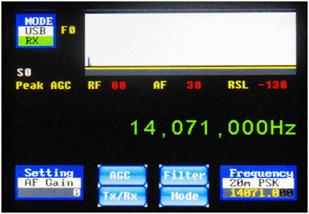

Figure 8: USB Operation Screen

For now, let's explore the **Setting** icon, which is visible on any of the operations screens, and also on the **Setting** screens themselves. Like the **Mode** icon, it is both a status indicator and a touch region. The top of the icon reminds you of its function (Setting). The middle portion tells you which Setting is selected. The lower portion displays the current value of the selected Setting. In Figures 8 (above) and 9 (below), the AF Gain Setting is selected, and its current setting is 0. You can adjust the value of the currently displayed setting with the left-hand rotary encoder, increasing the value by rotating it clockwise or decreasing the value by rotating it counterclockwise.

We'll now go through the many settings in some detail.

## Settings Screens

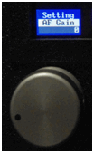

Figure 9: Setting Widget Above the Left Rotary Encoder

From any operational screen, touching the **Setting** widget (as in Figure 9 above), will bring you into the setup and adjustments screens. The first such screen is shown in Figure 10, below. There are six buttons on the left side which go directly to settings whose values you can set with the left rotary encoder. The five buttons on the right take you to sub-menus of the Settings menu for the functions that you will not need to change nearly as often.With those six most common settings, the rotation of the left-hand rotary encoder causes the value to change immediately (and the numeric value of the option to be displayed in the middle part of the option button/status widget).. You don't need to press any other button or do anything else for the adjustment to take effect. When you tap the on-screen Setting button again, this screen is exited, and you return to the previous screen. The setting item you most recently selected remains in the bottom left corner of the operation screen, and you can continue to adjust its value with the left-hand rotary encoder knob, even after you return to an operation (SSB/CW/PSK) screen.

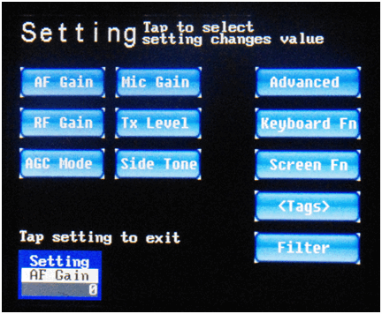

Figure 10: Main Settings Menu Page

### Main Settings

The first six settings are as follows:

* **AF Gain:** Volume control, adjusts the audio level of the headphone jack. Range is -127 to +48
* **RF Gain:** Increase for weak signals, and decrease for strong signals. Range is 0 to +80. If you have AGC enabled, leave it at 80.
* **AGC Mode:** Selects Peak AGC (mode 0), Digital AGC (mode 1), SSB AGC (mode 2), or AGC Off (mode 3). The AGC mode affects both how the AGC works and how the S-meter display value is calculated. See the AGC section for more details on this.
* **Mic Gain:** Adjusts the I/Q levels to the transmitter in SSB mode. Adjust for maximum level on the Spectrum view (to be described below) without causing any distortion of the signal. Range is 0 to 80, default is 20. A 50 mV input gives maximum output with a setting of 20 or 1 volt peak-to-peak.
* **Tx Level:** In CW and PSK modes, this control adjusts the level of the I/Q signal to the transmitter. Adjust this control for maximum modulation without distortion. Range is 0 to 29. Maximum is 1 volt peak-to-peak.
* **Side Tone:** Side tone level, adjusts the level of the side tone present in the headphones during CW transmit. Adjust to the desired level. Range is -6 to +29.

There are five other sub-menus that are accessed from this Settings screen:

* **Advanced:** Advanced settings that less frequently need to be adjusted.
* **Keyboard Fn:** Program in the actions of the Function keys (F1 to F12) on the attached keyboard. This is a new feature that was not present in the older v1.052 firmware.
* **Screen Fn:** Program in the functions of certain on-screen buttons. This is also a new feature that was not present in the v1.052 firmware.
* **<Tags>:** Program in the values of strings such as the PSK mode transmission strings, which are associated with a particular “tag name”. In the older v1.052 firmware, this button used to be called “Functions”.
* **Filter:** Set up bandpass filters that are automatically switched into place as you change frequency. (The bandpass filters are ***not*** a part of the IQ32; they must be obtained separately and integrated by you into the product. This menu simply assists you in configuring the radio to the external bandpass filter system of your choice so that it can operate as automatically as possible. This menu sets the values of the three output bits on the BPF connector for various ranges of operational frequencies, and it is assumed that the bits that are output select the proper bandpass filter.)

We will look at these five other buttons in some more detail shortly. But first, let's look over the **Advanced Settings** menu more closely.

### Advanced Settings

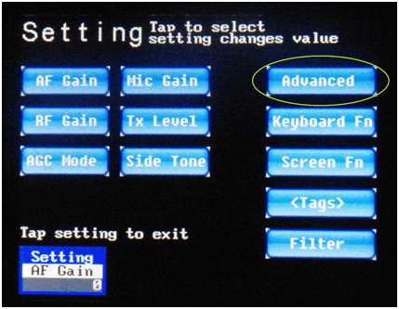

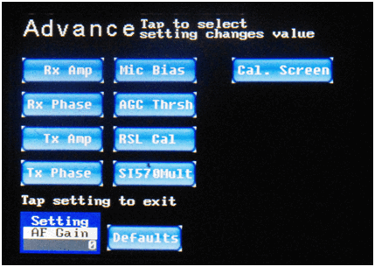

Figure 11: Advanced Settings Screen

On the main Settings screen (top half of Figure 11, below), if you tap on the **Advanced** button, you will be brought to the **Advanced Settings** screen (bottom half of Figure 11, below). Like before, the most often-used Advanced settings each have a button, which you tap, and then you adjust its value with the left rotary encoder. Again, the changes you make with the rotary encoder take effect immediately.

The **Advanced** menu (bottom half of Figure 11) contains a number of settings that were formerly contained on (the very cluttered) “Options” screen several firmware releases ago. These settings typically need to be set only once, or at most, only occasionally, such as if you change to a different microphone, or install a different RF front end.

The Settings available on the **Advanced Settings menu** are as follows:

* **Rx Amp:** This is the adjustment of the I/Q amplifier's voltage gain. This must be adjusted to maximize the suppression of the unwanted sideband. See the Adjustment section for more details. Range is 1,000 to 10,000.
* **Rx Phase:** This is the adjustment of the I/Q amplifier's phase gain. This must be adjusted to maximize the suppression of the unwanted sideband. See the Adjustment section for more details. Range is -10,000 to +10,000.
* **Tx Amp:** This is the adjustment of the I/Q amplifier's voltage gain. This must be adjusted to maximize suppression of the unwanted sideband. See the Adjustment section for more details. Range is 1,000 to 10,000.
* **Tx Phase:** This is the adjustment of the I/Q amplifier's phase gain. This must be adjusted to maximize suppression of the unwanted sideband. See the Adjustment section for more details. Range is -10,000 to +10,000.
* **Mic Bias:** This is either on (1) or off (0). If you are using an electret microphone you need this bias voltage to allow the microphone to work.
* **AGC Thrsh:** Adjusts the AGC Threshold, *i.e.*, the point where AGC starts to function. Default value is 400 for normal operation. Range is 50 to 1000. See AGC section for more details.
* **RSL Cal:** Adjust this to calibrate your S Meter. See the Adjustment section for more details.
* **SI570Mult:** Not used in the IQ32.

There are two other buttons of note on the Advanced Settings screen:

* **Cal Screen:** Use this button to calibrate the touchscreen if your taps are not activating the options you are trying to activate. This will bring you back to the screen calibration screens that you initially saw the very first time you turned on your system. As previously noted, if the calibration is sufficiently far out of whack, you won't be able to select this option by touching the screen. In that case, power down the IQ32, power it back up again, and promptly (and simultaneously) press both of the rotary encoders inwards. This selects the same calibration screens.
* **Defaults:** Use this button if you mess up these settings so badly that the radio is not operational, and you need to get everything set back to sensible values.

There are four other **Settings** screens that we need to cover, one of which first appeared in v1.052 of the firmware and two of which are brand new for release 1.059 of the firmware (not widely released) and later. We'll discuss all four of them now.

### Keyboard Fn Settings

If you are currently on one of the operational screens, tap on the **Settings** icon again to bring up the **Main Settings** screen (top part of Figure 12, below) like before. This time, however, instead of tapping on **Advanced**, tap on the **Keyboard** **Fn** button on the right side of the screen, which brings up the screen shown in the bottom part of Figure 12..

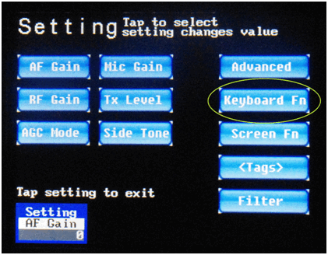

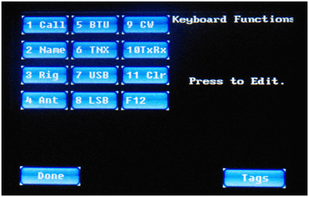

Figure 12: Setting → KeyboardFn Screen

The standard keyboard attached to your IQ32 system has 12 “function” keys across the top row. Typically, application programs can interpret these 12 keys any way that they choose to. The IQ32 firmware is no exception to this, and like many (but certainly not all) PC application programs, you can adjust how these function keys do what they do within the program.

From the Setting screen, touch the on-screen **KeyboardFn** button to get to the second screen shown in the lower half of Figure 12, above.

From this screen, you can touch any of the on-screen buttons grouped in the top left corner of the screen, numbered 1 – 12, which correspond to the twelve **F1** through **F12** keyboard buttons and adjust the function that it performs.

By default, the twelve function keys are dedicated to the following actions:

* **F1** Transmit your callsign (PSK mode only)
* **F2** Transmit your name and location (PSK mode only)
* **F3** Transmit information about your rig (PSK mode only)
* **F4** Transmit information about your antenna (PSK mode only)
* **F5** Transmit “back to you” message (PSK mode only)
* **F6** Transmit “Thank You” message (PSK mode only)
* **F7** Switch to USB mode with a single tap
* **F8** Switch to LSB mode with a single tap
* **F9** Switch to CW mode with a single tap
* **F10** Toggle between Receive Mode and Transmit Mode
* **F11** Clear out the PSK conversation window
* **F12** (Currently not in use.)

To control exactly how these keyboard function keys act, tap on the corresponding button on the screen. You will then be able to use your keyboard to modify the action of the key, within certain limits. Let's look at them one-by-one.

Tap on the on-screen button #1 named “1 Call”. This will produce a display as shown below, in Figure 13:

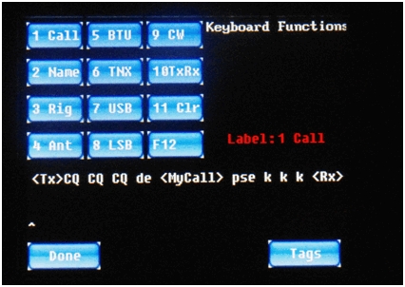

Figure 13: Function Key F1 Setting Screen

As seen above (in Figure 13), pressing the **F1** function key while in PSK mode will **turn on the transmitter** (with the **<Tx>** operator, see Appendix 1), send out **CQ** (“seek you”) three times, then send “**de**” (French and typical CW/PSK abbreviation for “from”), then send out your **Amateur Radio Callsign** (with the **<MyCall>** tag, see the <Tags> section below), then send out the abbreviation for “please” (“**pse**”) and three copies of the abbreviation for “OK” (“**k k k**”). The IQ32 is then **switched to receive mode** (with the **<Rx>** operator, see Appendix 1). Note that there is room for up to two lines of text/commands/tags on the screen, and the cursor (the **^** character) is shown below the second line of the editing buffer. You should also note that with firmware release v1.059 and later, the editing of these strings is a lot less primitive than it was in earlier versions of the firmware. You can now use the **LEFT ARROW (**←**)** or **RIGHT ARROW (**→**)** keys to move the cursor into the middle of a string, and then add or delete text. The **TAB (**→**|)** key switches between editing of the string and the key's label. The **UP ARROW (**↑**)** and **DOWN ARROW (**↓**)** keys allow you to switch to a different item to be edited. Also, holding a key down will cause it to start repeating, after a brief delay.

For example, you could position the cursor and remove one of the three CQ's or insert a fourth CQ. In the past, if you wanted to make such a change at the CQ's near the beginning of the string, it was necessary to use the **BACKSPACE** key to delete everything to the right of your desired edit point, make your change, and then re-type anything that you were forced to delete but really wanted to keep. No more!

Once you have configured the operation of the **F1** function key as desired, tap on the **Done** button to return to the current operating screen.

Note that you can also tap on the **Tags** button to switch to editing of the values of the internally-stored tags. This is a shortcut, so that you don't have to tap on **Settings** then **Advanced Settings** and then **<Tags>**. The **<Tags>** will be described in more detail shortly.

In a similar manner, you can fine-tune the actions performed by the **F2** through **F12** keyboard function keys. Let's run through the default programming of those keyboard function keys, one at a time.

From the **Keyboard Fn Settings** screen, tap on the on-screen button #2, which is labeled “2 Name”. Keyboard button **F2** is used in PSK31 mode to send your name and your location (QTH) to the station you are working. You should see something like Figure 14, below, after tapping on the second on-screen button.

As you can see, the standard firmware comes programmed to send the string “**My name is** “, followed by **your name** (as stored in a <Tag> called **<MyName>**), followed by the string “**and my QTH is**”, followed by **your operating location** (as stored in a <Tag> called **<QTH>**).

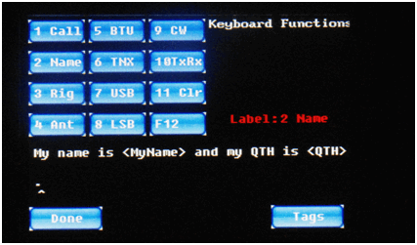

Figure 14: Function Key F2 Setting Screen

There is a **Done** screen button that you use when you are done editing this keyboard function, and a **Tags** button which is a shortcut to the editing of the <Tags> strings.

Keyboard function key **F3** is used while in PSK mode when you want to send information about your rig . If you pick this button, you will see something like Figure 15, below:

As you can see in Figure 15 above, the default action of this key is to send the string “**My rig is an**” followed by the string programmed into the <Tag> which is named **<Rig>**.

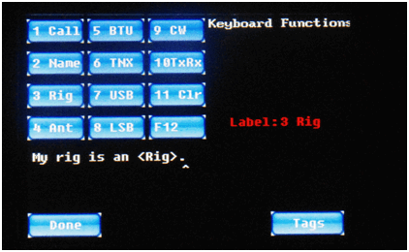

Figure 15: Function Key F3 Setting Screen

Keyboard function key **F4** is set up to send information about your antenna when you are in PSK31 mode. If you tap on this on-screen button, you will see something like Figure 16, below:

As you can see, the default action is to send the string “**My ant is a**” followed by the string which has been programmed into the <Tag> named **<Ant>**.

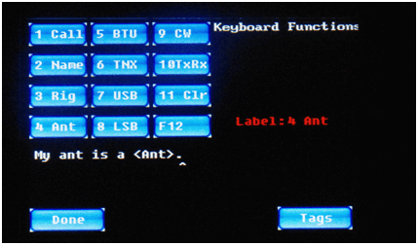

Figure 16: Function Key F4 Setting Screen

Keyboard function key **F5** is used near the end of a PSK-31 QSO. The label on the screen for function key **F5** is “BTU” which is short for “**Back to You**”. You can see this if you select the fifth button from the **Keyboard Fn** menu, after which you should see something like Figure 17, below. In total, the default action of the **F5** function key is to transmit “**Well** “, then **the name of the station with whom you are conversing** (in the <Tag> called **<StnNM>**), followed by “**, BTU**” (Back To You) followed by **the callsign of the station with whom you are conversing**, (from the **<StnCS>** tag) followed by “**de**” (from) followed by **your callsign** (stored in the **<MyCall>** tag) followed by “**kn**”, after which **the radio is switched to receive mode** with the **<Rx>** macro. Examine Figure 17, below, to see all of these programming details.

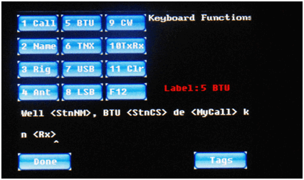

Figure 17: Function Key F5 Setting Screen

Keyboard function key **F6** is used to send your “Thank You” at the end of a PSK-31 QSO. You can customize this by tapping on the sixth on-screen button, which should bring up a setting screen similar to Figure 18, below:

The string stored in this location and transmitted when you press keyboard function key **F6**, by default, is shown above as **TNX** (“thanks”) **for the PSK31 QSO.** (conversation). **73's** (Best wishes).

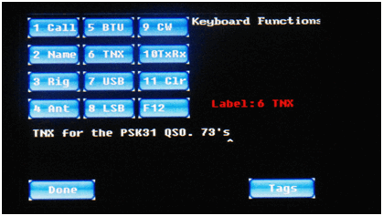

Figure 18: Function Key F6 Setting Screen

The response to keyboard function key **F7** is programmed by default to change the IQ32 to USB (Upper Side Band) mode, as can be seen in Figure 19, below. Note that this is accomplished by issuing the **<USB>** macro.

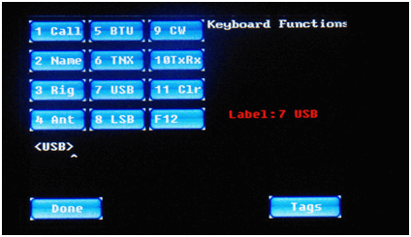

Figure 19: Function Key F7 Setting Screen

Keyboard function key **F8** is programmed by default to change the IQ32 to LSB (Lower Side Band) mode, as can be seen in Figure 20 , below. Similar to the prior example, this is accomplished by issuing the **<LSB>** macro.

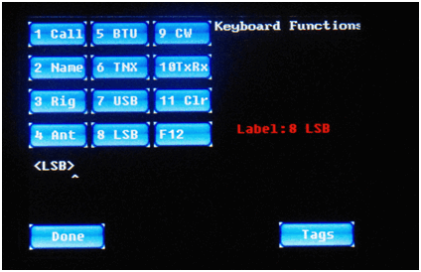

Figure 20: Function Key F8 Setting Screen

Keyboard function key **F9** is programmed by default to change the IQ32 to CW (Continuous Wave or Morse Code) mode, as shown in Figure 21, below. Similar to the **<USB>** and **<LSB>** macros, this is accomplished by issuing a macro named **<CW>**. If you are attempting to make a contact on SSB and the other station is simply not hearing you well enough to make out your callsign, for example, you might want to quickly switch to CW mode and send your information, knowing that CW signals are often discernible under conditions where SSB signals are inadequate (and hoping that the other station understands Morse Code!). Instead of hitting the on-screen Mode widget and then the on-screen CW button to accomplish this, you can simply press the **F9** function key on your attached keyboard and jump directly to CW mode. The programming of the **F9** key is shown in Figure 21, below.

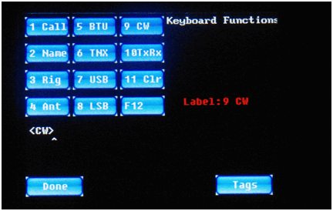

Figure 21: Function Key F9 Setting Screen

Function key **F10** is used to toggle between Receive Mode and Transmit Mode. This simply means that if the IQ32 is currently in Receive Mode, pressing the **F10** key on the keyboard will switch over to Transmit Mode. The next subsequent press of the **F10** key will switch back from Transmit Mode to Receive Mode. Selecting screen button 10 from the **Settings | Keyboard** menu will look similar to Figure 22, below.

Note the new command macro, **<Tx/Rx>**. As described in the Appendix, this macro toggles the state of the IQ32 transmitter – to ON if it is currently OFF, and to OFF if it is currently ON.

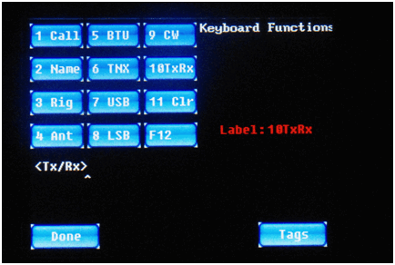

Figure 22: Function Key F10 Setting Screen

Keyboard Function Key **F11** is used in PSK-31 mode to empty out the transmit buffer in preparation for the user to type in a new string of text to be sent. So, picking button 11 on the **Settings | Keyboard** menu looks like Figure 23, below: This is accomplished by issuing a command macro called **<Clear>**.

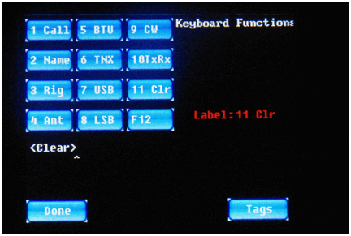

Figure 23: Function Key F11 Setting Screen

Keyboard Function Key **F12** currently has no assigned function, so in the default firmware, the **KeyboardFn** menu shows the button set to a value of “This is F12”, as shown in Figure 24, below. This is OK as a placeholder while you are becoming familiar with the IQ32 settings, but you may want to delete this string, so if you accidentally bump the **F12** key during the middle of a PSK-31 QSO, that message will not be sent out to the station you are working. Anyway, the Settings screen for the **F12** keyboard button, as the firmware is currently programmed, looks like Figure 24, below.

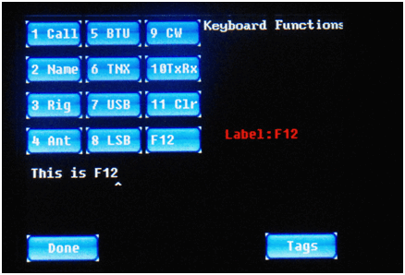

Figure 24: Function Key F12 Setting Screen

### Screen Fn Settings

The next sub-menu of the **Settings Menu** screen is the **Screen Fn** sub-menu, which is illustrated in Figure 25, below.

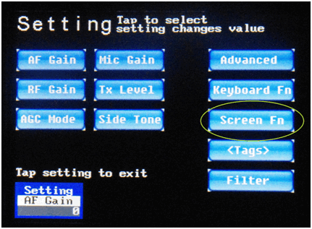

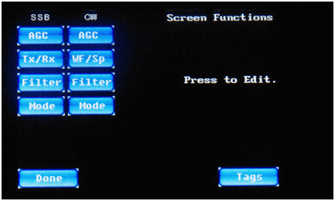

Figure 25: Settings → Screen Fn (Button) Setting Screen

The idea here is that on the operation screens (SSB, CW, and PSK screens), there are ten programmable on-screen buttons. These buttons can be programmed to perform specific functions. As shipped, the firmware is shipped with 4 buttons on the SSB screens (either USB or LSB), 4 buttons on the CW screens (either CW or CWR), and 2 buttons on the PSK screens (either PSK-U or PSK-L). Eight of these ten buttons are configured on the **Screen Fn** menu screen. (The PSK buttons are handled differently.)

You are able to edit the label on the button as well as the function that it performs. You change the function invoked by one of these buttons by programming in one or more “macro tags” on this screen. We have already seen a couple of the macro tags earlier, when we were discussing the programming of the keyboard function keys, namely the **<Tx>** macro to turn on the transmitter and the **<Rx>** macro to turn off the transmitter and return to receive mode, the **<Rx/Tx>** macro to toggle the transmitter to its opposite state, and the **<USB>**, **<LSB>**, and **<CW>** macros to change operation modes. The complete list of available macro commands can be found in Appendix 1.

The buttons on the Screen Fn settings menu are arranged in two columns, one for the buttons on the SSB operation screens, and one for the buttons on the CW operation screens. The two PSK buttons are programmed right from the PSK operation screen, not here, for reasons that will be clearer when we discuss PSK operation.

Most of the 8 buttons are programmed with new command macros that you have not seen before, unless you skipped ahead and took a look at Appendix 1. Let's see how they are programmed by default.

Figure 26, below, shows the programming of the **AGC** button when in SSB mode (either USB or LSB). As seen there, the default programming of this on-screen button causes the IQ32 to cycle to the next possible AGC setting. Recall from earlier discussion (on the Settings menu) that there are four possible AGC settings: Peak AGC (mode 0), Digital AGC (mode 1), SSB AGC (mode 2), or AGC Off (mode 3). You can quickly cycle through these 4 modes right from the SSB operation screen by touching the on-screen AGC button, instead of touching the Settings widget in the bottom left corner, then picking AGC, then rotating the left-hand rotary encoder, then touching the Settings widget again to return to the operating screen. This shortcut is much more convenient. Note that the on-screen **AGC** button is programmed by invoking a new macro called **<NxAGC>** (which means “next AGC mode”. Again, refer to the Appendix for a list of all the available command macros.

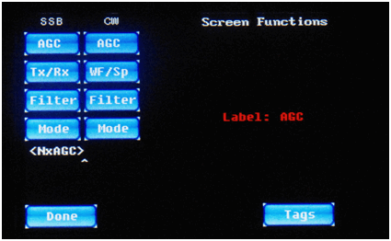

Figure 26: SSB AGC Screen Button Programming Screen

Figure 27, below, shows the programming of the on-screen **Tx/Rx** button in SSB mode. Normally, you would only use such a button on the SSB screens, and even then, it is not absolutely essential if you have either a keyboard or a CW key attached, because the keyboard **F10** key or the CW key could be used instead of an on-screen button. But if you were operating without either input device, you could still use SSB mode with this on-screen button. Let's look at how the on-screen button is programmed by default.

As can be seen in Figure 27 above, this button is programmed to invoke a macro that we have already seen before, namely the **<Tx/Rx>** macro, which is, by default, also programmed for invocation by the **F10** keyboard function key. It switches the transmitter into transmit mode if currently receiving, or into receive mode if currently transmitting

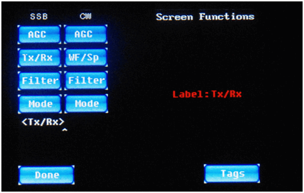

Figure 27: SSB Tx/Rx Screen Button Programming Screen

.

Figure 28, below, shows the programming of the on-screen button labeled **Filter** on the SSB operational screens.

As can be seen from Figure 28 above, the default setting of the on-screen **Filter** button when in one of the SSB modes is to select one of the audio filter settings that are appropriate for SSB operation. The macro **<NxFil2>** means “select the next of either no filter or one of 2 filters, *i.e.*, No Filter, Filter 1 (300-3300 Hz), or Filter 2 (300-2700 Hz), starting from the current filter setting”. Only the two widest filter settings (or No Filter) can be selected, because narrower filters are too narrow for proper SSB operation.

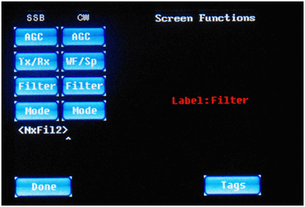

Figure 28: SSB Filter Screen Button Programming Screen

The fourth programmable on-screen button for the SSB operational screens is labeled **Mode**. This is demonstrated in Figure 29, below.

This screen button, by default, cycles through the available operational modes, *i.e.,* USB→LSB→CW→PSK-U→PSK-L→USB and also clears the audio filter (in case the current audio filter is too narrow for proper operation of the next mode). Note the use of two new macros (defined in the Appendix) called **<NxMode>** (to pick the next mode) and **<NoFilt>** (to select the option of no audio filter).

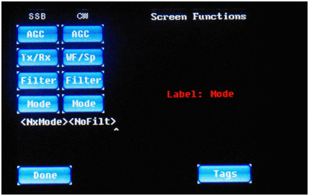

Figure 29: SSB Mode Screen Button Programming Screen

You can also program four similar buttons on the CW operational screens, as seen in Figures 30 through 33 below:

The **AGC** Mode button (Figure 30, above) is programmed by default the same way on the CW operational screen as previously discussed for the SSB screens, namely by using the **<NxAGC>** macro to cycle to the next AGC mode, one mode per button tap.

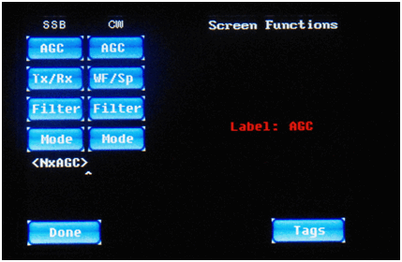

Figure 30: CW AGC Mode Screen Button Programming Screen

In CW modes, the second on-screen button is programmed quite differently than in SSB modes, because it is assumed that the IQ32 will stay in receive mode most of the time and will automatically switch to transmit mode when the CW key is activated. Therefore, there is no need for an on-screen **Tx/Rx** button. Instead, the second on-screen button is labeled **WF/Sp**, as seen in Figure 31, above. This toggles between the **Waterfall** DSP display and the **Spectrum** DSP display, by invoking the **<WF/Sp>** macro. These DSP displays are discussed later in this document.

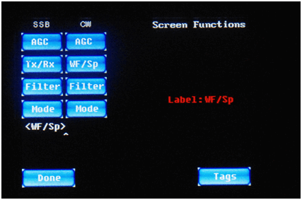

Figure 31: CW WF/Sp Mode Screen Button Programming Screen

In CW modes, the on-screen **Filter** button works similar to the same-named button in SSB modes, but not exactly the same. See Figure 32, below.

Note the subtle difference from the same-named button on the SSB screens, namely that the Filter button is able to select among any of the 5 available filters, or no filter at all, instead of only the two widest filters. In other words, the choices cycle among No Filter (0-4000 Hz), Filter 1 (300-3300 Hz), Filter 2 (300-2700 Hz), Filter 3 (300-1300 Hz, too narrow for SSB), Filter 4 (400-700 Hz, much too narrow for SSB), and Filter 5 (500-600 Hz, far too narrow for SSB). This is accomplished, as seen in Figure 32 above, with the **<NxFil5>** macro (“next filter of 5”) instead if the **<NxFil2>** macro.

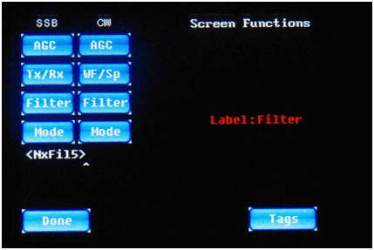

Figure 32: CW Filter Screen Button Programming Screen

Finally, like we saw on the SSB button options, the fourth button option on the CW operational screens is a button that cycles through the available operational buttons so that you don't have to use the **Mode** widget to manually pick a different operational mode.

As seen in Figure 33 above, the default programming for this button is to pick the next operational mode with **<NxMode>** and disable the audio filter with **<NoFilt>**.

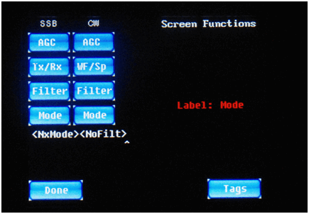

Figure 33: CW Mode Screen Button Programming Screen

The two other screen buttons, which appear on the PSK screens, are not programmed here. Instead, they are programmed right on the PSK screen, because their values would be changed more often, with every new PSK contact. Therefore, they will be discussed when we get to the PSK operation section of this manual.

### <Tags> (PSK Macro) Settings

From the Settings screen, the **<Tags>** setting button brings up a screen that is familiar to users of older versions of this firmware. As shown in Figure 34 below, this is where you are able to enter in strings of text (and, optionally, macro commands) that are used during PSK-31 operation.

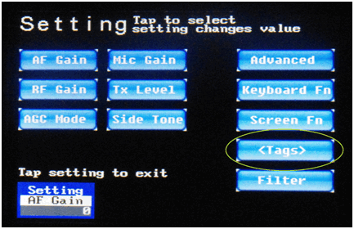

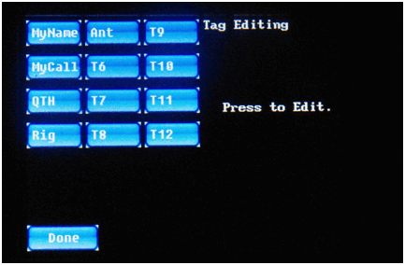

Figure 34: Settings → <Tags> Screen

You tap on the on-screen button for the <Tag> that you want to edit, and then edit it, using any of the new keyboard editing features added in this release.

The first 5 buttons are fairly self-explanatory: **MyName** = your name, normally just your first name; **MyCall** = your Amateur Radio callsign; **QTH** = your home or operating location. You may want to put City & State, or your Maidenhead Grid Square, or both (if there is room). **Rig** = your radio hardware, for example “STM-32 SDR”; and **Ant** = your antenna. The **T6** through **T12** tags are available for future uses that you can think up.

There is no longer a need to tap on a **Store** button (and one is no longer present) to save your edited value(s) into EEPROM. Just tap **Done** when you are done.

Figures 35 through Figure 40 show the editing of the default <Tag> values.

In the default firmware, your name is pre-programmed in as “John Doe”, as can be seen in Figure 35. We presume that most of you will want to change this to your own name, as no one with that name seems to have an Amateur Radio license (as far as we can determine), at least not in the USA or Canada.

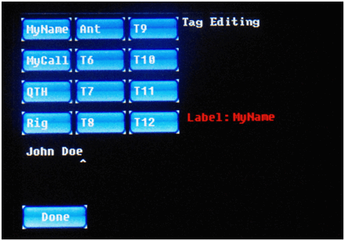

Figure 35: MyName <Tag> Programming Screen

In the default firmware, your callsign is pre-programmed in as “A1BCD”, as seen above in Figure 36. Once again, we presume that you will want to change this to your own callsign, particularly since there seems to be no one with this USA-format callsign in the United States who actually holds this particular Amateur Radio callsign.

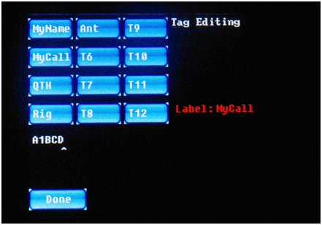

Figure 36: MyCall <Tag> Programming Screen

In the default firmware, your QTH is pre-programmed in as “My Home”, as can be seen above, in Figure 37. You should probably change this string to reflect either your home (city, state/province, Maidenhead Grid Square), or some other indication of the location from which you are operating.

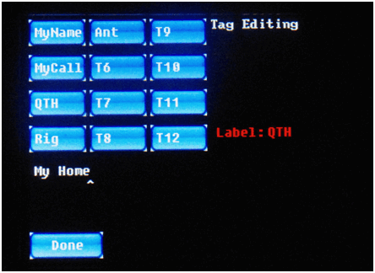

Figure 37: QTH (location) <Tag> Programming Screen

In the default firmware, your rig is listed as an “STM-32 SDR”, as can be seen above in Figure 38. You can change this to IQ32. If you do make such a change, and you are a perfectionist, you will want to change the definition of the keyboard **F3** key from “My rig is an” to “My rig is a”. (As Spider-Man's Uncle Ben once said, “With great power comes great responsibility.”)

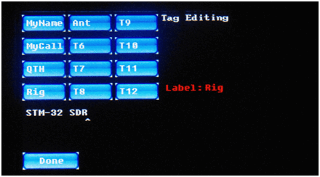

Figure 38: Rig (radio type) <Tag> Programming Screen

In the default firmware, the antenna is described as a “Dipole”, as shown in Figure 39, above. If this is accurate, you can leave it. If not, you can change it.

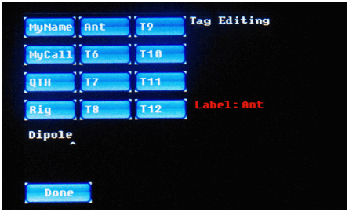

Figure 39: Ant (antenna type) <Tag> Programming Screen

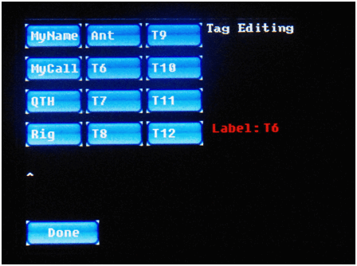

Figure 40: T6 (Tag #6) <Tag> Programming Screen

Tags **T6** through **T12** are presently unused, but are available for your use. Since they are all defaulted to blank, as shown above in Figure 40, we are only bothering to show the editing of **T6** above, in Figure 40. But we feel sure that you get the proper idea. After all, you were smart enough to purchase an IQ32 Software-Defined Radio, weren't you?

### Bandpass Filter Settings

These settings are a hold-over from the original STM-32 SDR project and have no impact on the IQ32.

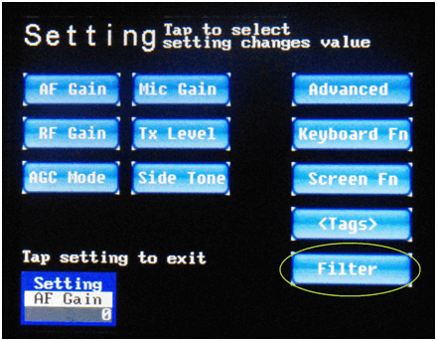

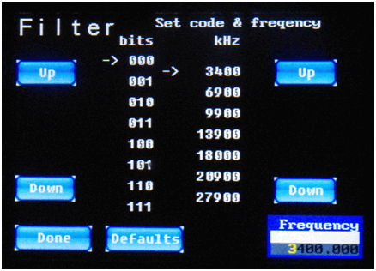

Figure 41: Settings | Filters Screen

.

**Frequency Tuning**

The **Frequency** icon, like the **Settings** icon or **Mode** icon, is a touch area on the screen and a status indicator. The top line contains the title “Frequency”. The middle contains the named frequency when an operation screen (CW, SSB, PSK-31) is active (see Figure 42 below, to be explained further a bit later in this document), or a blank white bar on the Settings screen for the bandpass filters (as previously shown in Figure 41, above). The bottom line of the icon is the current frequency. The current frequency is adjusted by rotating the right encoder clockwise to increase and counter-clockwise (or, if you prefer, anti-clockwise, to some of you blokes) to decrease the frequency.

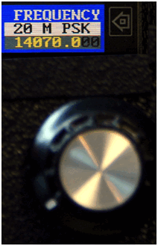

Figure 42: Right Encoder Being Used to Tune a Frequency.

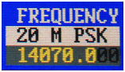

Figure 43: Frequency Adjustment Icon

You can adjust the step size or tuning step of the frequency by pressing and holding in the right rotary encoder, and rotating right (clockwise) for smaller steps (more digits) or left (counter-clockwise) for larger steps (fewer digits). At power up, 100 Hz steps are selected. Figures 42 and 43 show that 14070.0 is highlighted in yellow and the final two zeros are grey, so the tuning step is 100 Hz.

Figure 44 shows the minimum tuning step of 1 Hz, with all digits in yellow, and Figure 45 shows the maximum tuning step of 100000 Hz (100 Khz or 0.1 MHz), with only the first 3 digits (“140”) in yellow.

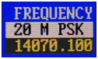

Figure 44: Minimum Tuning Step of 1 Hz

This tuning step adjustment allows you to tune between 2000.000 KHz (2 MHz) and 500.000000 MHz. This, of course, is limited to 3.5 to 30 MHz in the IQ32



Figure 45: Maximum Tuning Step of 100 Khz (0.1 MHz)



Figure 46: Done Button

## Frequency Manager Screen

While we are on the subject of frequency selection, there is another menu screen to discuss. When you are on an operating screen (CW, SSB, PSK, *not* on the bandpass filter setting screen), touching the **Frequency** icon launches the frequency manager (seen below in Figure 47) where you can easily select one of 15 different presets, or edit the values stored in the 15 presets. Starting with this firmware release, you can not only change the frequency value associated with those 15 presets, but also you can change the descriptive name on the button and the operational mode (USB, LSB, CW, CWR, PSK-U, PSK-L) that is activated when you pick one of the presets.

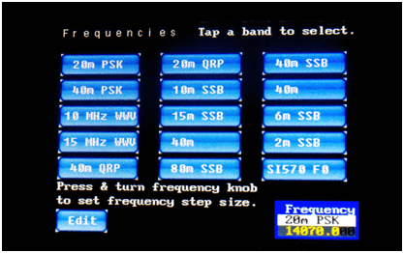

Figure 47: Frequency Manager Screen

From the Frequency Manager screen (Figure 47, above) you can tap on one of the top 15 buttons to go directly to that mode and frequency of operation, or you can tap on the **Edit** button in the bottom left corner. Let's do that, and see how the new editing features are implemented. Once you press the Edit button, the Frequency Manager screen changes to something like you see below in Figure 48.

The changes include the altered title line which now instructs you to tap on one of the buttons to pick the one you wish to edit, and the addition of a Mode button because you are now able to edit all three aspects of each button – its label, its frequency, and its operational mode. Let's tap on the first button, which by default, is labeled **20m PSK**. The screen will change subtly once again, as seen in Figure 49, below.

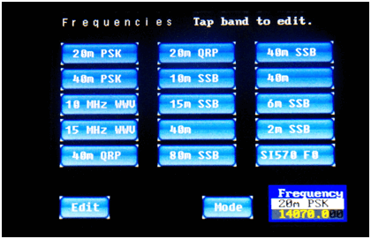

Figure 48: Editing a Button on the Frequency Manager Screen

Note that there is now a line of information in white text between the 15 preset buttons and the **Edit** button / **Mode** button / **Frequency Widget**. This line has two fields, one for the **Label** (what text is placed on the button, default is shown as **20m PSK**) and the other for the **Mode** (mode of operation, default shows as **LSB**). The text cursor (shown as a caret or '**^**') is placed at the end of the button's current label.

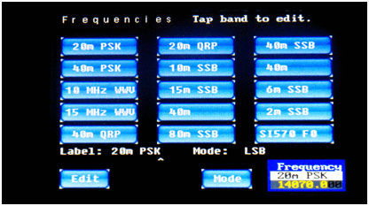

Figure 49: Editing the 20m PSK Button

From here, the **UP ARROW (**↑**)** and **DOWN ARROW (**↓**)** keys on your keyboard will allow you to scroll through the 15 preset buttons, in case you accidentally did not hit the button you really wanted to edit. The **LEFT ARROW (**←**)** and **RIGHT ARROW (**→**)** keys allow you to move the cursor to a specific location within the text string so that you can add or delete characters at a particular location, instead of having to destructively **BACKSPACE** over everything from the end of the string to the location you want to change. For example, if you wanted to change the button label's “**20m**” portion to read “**20 M**” instead, you could use the **LEFT ARROW (**←**)** key to back up the cursor as shown in Figure 50, below.

Just for fun, try pressing the keyboard **DOWN ARROW (**↓**)** key. This will yield a screen like Figure 51, below.

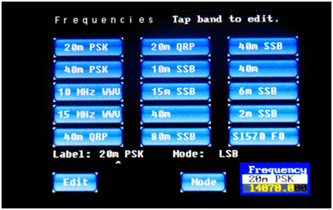

Figure 50: Editing Within the Label of the 20m PSK Button

What happened? Moving the cursor down picked the next on-screen button for editing. We switched to the editing of the **40m PSK** button instead of the **20m PSK** button.

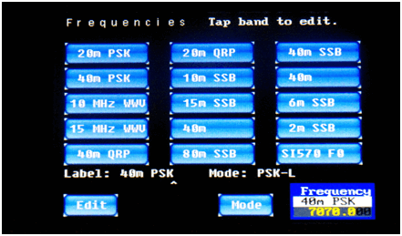

Figure 51: Editing a Different Button

As already mentioned, you can use all of the keyboard editing controls to edit the label on the button.

You can use the **Mode** button to change the mode of operation that is selected by this button. Repeated taps of the **Mode** button cycles through the available operational modes, namely CW→CWR→PSK-U→PSK-L→USB→LSB→CW (and around again).

Along with the 14 ordinary frequency presets, there is also a **SI 570 F0** frequency button that is important to adjust for your particular RF front-end radio. More details on this will be given in the radio setup section.

It should also be noted that in the earlier versions of the firmware, in spite of the titles on these buttons, they *only* changed the *frequency* to which you were tuned, they *did not* change the *mode* of operation from SSB to CW or to PSK, or vice versa. Happily, this is no longer true!

When you return to the operational screen your changes are automatically stored in the EEPROM so they will also be set the next time you turn on your IQ32.

## Receive Filter Settings

Another recent and long-awaited feature of this firmware release is the addition of control over the received bandwidth filtering. Prior to release 1.054, the signal heard in the headphones was the entire 4 KHz RF signal bandwidth. This is now adjustable!

On the three operational screens (CW, SSB, and PSK), to the right of the **Mode** icon and to the left of the FFT (Waterfall or Spectrum) display, you will see a new annotation, the 2 characters in yellow text, F0, F1, F2, F3, F4, or F5. This indicator is telling you what received bandwidth filter is in operation. The filter bandwidth is also indicated graphically by the width of the yellow line between the FFT window and the S Meter. The six bandwidths are selected by pressing in on the left-hand rotary encoder and releasing it. (No rotation is needed.) Each press and release cycles you from the current filter to the next narrower filter, until the narrowest one is reached, at which time you wrap around to the widest one all over again. The six filter bandwidths are as follows:

* F0 = 4,000 Hz (the old default in the earlier firmware)
* F1 = 2,700 Hz
* F2 = 2,400 Hz
* F3 = 1,000 Hz
* F4 = 300 Hz
* F5 = 100 Hz

Remember, subsequent depressions of the left-hand rotary encoder knob select the bandwidths F0 → F1 → F2 → F3 → F4 → F5 → F0 and so on over again...

As you may recall, we previously mentioned that there are on-screen buttons (on the SSB and CW operational screens) that allow you to select the audio bandpass as well. The on-screen buttons, however, only allow selection of audio bandwidths that make sense for the operational mode. In SSB modes, only F0, F1, or F2 are selectable with the on-screen button. In CW modes, any of the six bandwidths, F0 through F5, can be chosen. The PSK operational screens do not have an on-screen **Filter** button, so selection of the audio bandwidth can only be made with the left-hand rotary encoder.

That covers basic navigation of the firmware. The next sections will give you some more details on the three basic modes of operation, examples on how to setup a radio, and further information on how to adjust settings.

# CW Operation

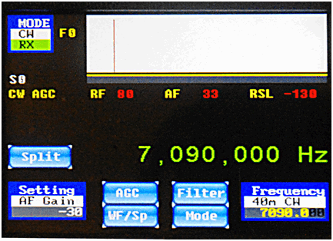

Figure 52: CW Operation Screen

The CW operation screen contains all of the controls and indicators that are required for CW operation.

The **Mode** icon / widget is shown in the upper left (CW), along with the State (RX).

The **Setting** icon / widget is displayed on the lower left. This shows which option is currently controlled by the left hand encoder (AF Gain) and its present value (-30).

The **Frequency** icon / widget is shown on the lower right (7.090 MHz) and the tuning step is 100 Hz as indicated by the “grayed out” least-significant two digits of the frequency. It also shows the alpha numeric tag associated with the frequency preset, in this case, 40m CW. The button associated with this frequency preset was programmed to be in CW mode. Remember, in this version of the firmware, the **Frequency** widget selects both a frequency and a mode at once from the frequency manager window, a significant improvement over earlier firmware.

As discussed in the Settings section of this manual, there are another 4 programmable control buttons on the screen, marked **AGC**, **Filter**, **WF/Sp,** and **Mode**.

The **AGC** button selects the Automatic Gain Control mode. The **Filter** button selects the audio filter bandwidth, as does the depressing of the left-hand rotary encoder, which was formerly the only way to select the filter bandwidth. The **WF/Sp** button toggles the signal display area of the screen between **Waterfall** view (Figure 56) and **Spectrum** view (Figure 57). The **Mode** button allows you to jump to a different operational mode (CW, CWR, USB, LSB, PSK-U, PSK-L) without having to go through the Frequency Manager screen.

Very new to this firmware release is a 5th on-screen button labeled **Split** which, not surprisingly, is used if you want to operate CW in split mode, *i.e.,* with one frequency for receive and a different nearby frequency for transmit. This is often done during a pile-up with a highly-sought DX station. You listen on the frequency where the DX station is transmitting, but they listen on a different, announced frequency, such as 1 KHz higher in the band. Let's see how this is done with the IQ32.

From the basic CW operational screen (Figure 52, above), tap on the on-screen **Split** button. The display will change to something like Figure 53, below.

You then tune to the desired transmit frequency. In this example, we tuned to 7.091 MHz, or 1 Khz higher than the receive frequency. Once you have set the transmit frequency, you tap on the button which was re-labeled as **SetTx** instead of **Split**.

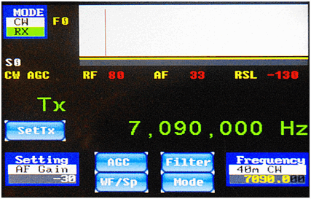

Figure 53: CW Split Operation Setup Screen

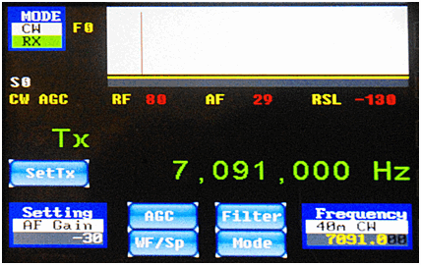

Figure 54: CW Split Operation – Transmit Frequency Screen

After you tap on SetTx, the screen will change to look like Figure 56, below, with both the receive frequency and the transmit frequency displayed in large bright green digits.

This screen (Figure 55, above) shows the operation of CW in split-frequency mode. The Tx frequency (7.091 MHz in this example) and the Rx frequency (7.090 MHz in this example) are both displayed. If you no longer wish to operate in split mode, note that the button we earlier used to initiate Split mode is now re-labeled **Join**, which means that it is used now to disable Split mode and Join the Tx frequency with the Rx frequency. Tapping that on-screen button will return you to a screen like we saw earlier in Figure 52.

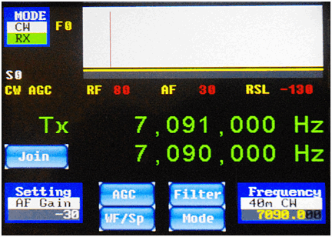

Figure 55: CW Split Operation Screen

The large box on the upper right of the screen (Figures 52 through 55) is the FFT window. This is the most interesting part of the display and one feature that makes this product unique. The FFT (Fast Fourier Transform) analysis can be displayed in one of two different formats. The previous figures showed the FFT operating in Spectrum Mode. The other mode is the Waterfall mode. You can switch between the two FFT display modes with the **WF/Sp** on-screen button.

The FFT spectrum view (Figure 56) shows you a spectrum display or panadapter view of a 4 kHz portion of the spectrum. It may be possible in later firmware versions to see a larger chunk and eventually a user selectable portion. The height of the blue pixels relates to the strength of signals in the window. The position (left to right) corresponds to the frequencies in the window. The red line indicates the tuned frequency.

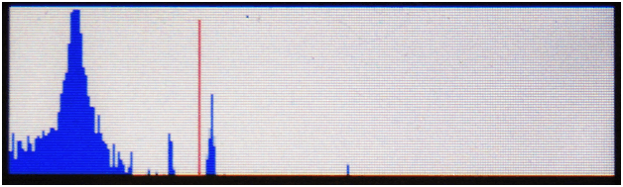Figure 56: FFT Spectrum View (Detail)

This Spectrum display allows you to see other signals in your 4 KHz chunk of the radio spectrum. Of course, a higher blue bar means a stronger signal.

The Waterfall view (Figure 57 is a more complex way to view signals, with both a time and intensity shown on the screen. The signal strength is shown in colour, ranging from black (no signal) to red (a very strong signal). The color display slides downward in time on the screen, so instead of showing only the current signal status, it shows a short history of what the signals have been. For any digital signals like CW or PSK, it's a wonderful way to look at the world.

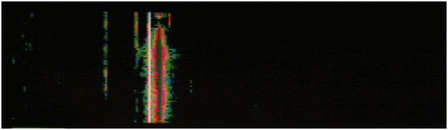Figure 57: FFT Waterfall View (Detail)

Hitting the **WF/Sp** on-screen button toggles between the two perspectives. Tune to the desired frequency using the right hand rotary encoder and the frequency manager.

You will also notice on the display there is an S meter, both numerically and with a bar graph. (Figure 58)

Select AGC mode 0 for an accurate S Meter reading in CW. If you have AGC turned off, you will have to adjust the RX RF control. Adjust the AF Gain to a comfortable level.

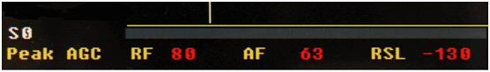

Figure 58: S Meter and Other Interesting Numbers

The display (Figure 58) shows the AGC mode selected (Peak AGC is currently selected, but CW mode would be best for CW). It shows RF gain is 80, AF is 63 and a Received Signal Level (RSL) is -130 dBm. Basically, in this display, no signal has been detected so the S meter reads S0. See section on AGC if you are really curious about how this all works. The horizontal yellow line is indicative of the audio filter width. In this figure, no audio filter has been selected (F0) so the full 4 KHz width is audible.

# SSB Operation

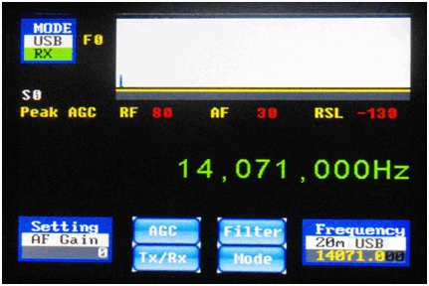

Figure 59: SSB Operation Screen

The SSB operation screen contains all of the controls and indicators that are required for SSB (either Upper Sideband – USB, or Lower Sideband – LSB) operation.

The **Mode** is shown in the upper left (USB) along with the State (RX).

The **Setting** is displayed in the lower left corner. This shows which option is currently controlled by the left-hand rotary encoder (AF Gain) and its present value (0).

The **Frequency** widget is shown on the lower right corner (14.071 MHz) and the tuning step is 100 Hz (as indicated by the “grayed out” two least-significant-digits of the frequency). It also shows the alpha numeric tag associated with the frequency preset, in this case **20m USB**. Once again, note that this is no longer just a label; in this version of firmware it is possible to select the frequency and mode of operation at the same time from the frequency manager screen by programming the button accordingly.

There are four control buttons on the screen, one marked **AGC**, one marked **Tx/Rx**, one marked **Filter**, and one marked **Mode**.

The **AGC** button controls the selection of the Automatic Gain Control. Repeated taps on this button cycle through the various AGC modes.

The **Tx/Rx** button controls if the unit is in Transmit (Tx) or Receive (Rx). It is a toggle button. Pressing the **Tx/Rx** button when in Receive will cause the unit to transmit (assuming that your RF unit supports transmit). When in Transmit, another press returns the system to Receive mode. Alternatively, you can also accomplish the initiation of transmission by closing the CW key while in SSB mode, or by pressing the **F10** key on an attached keyboard.

The **Filter** button allows selection of the audio bandpass filter, as previously discussed..

The **Mode** button allows you to quickly change to a different operational mode (CW, CWR, LSB, USB, PSK-L, PSK-U).

A microphone is plugged into the pink 3.5mm jack, and a set of headphones is plugged into the green 3.5mm jack. The firmware supports manual state switching (MOX) and a PTT button connected at the CW key input jack. The large box on the upper right of the screen (Figure 59) is the FFT Spectrum window. This is the most interesting part of the display and one feature that makes this product unique.

The FFT Spectrum window shows you a spectrum display, or panadapter view of a 4 KHz portion of the spectrum. Future firmware versions might someday allow you to see a larger chunk of spectrum, and eventually see a user-selectable portion. This will be limited by hardware speed and software capabilities (FFT processing capability and number of pixels on the LCD screen available to display the FFT).

The current firmware now has selectable filtering bandwidths in six steps, from a full 4,000 Hz to a minimum of 100 Hz. As previously discussed, you access the various filter bandwidths by simply pressing in on the left-hand rotary encoder. Each press selects the next narrower filter from the list (F0 = 4.0 KHz, F1 = 2.7 KHz, F2 = 2.4 KHz, F3 = 1.0 KHz, F4 = 300 Hz, and F5 = 100 Hz) and indicates this in two ways: with a 2-character yellow indicator (F0 through F5) between the **Mode** icon and the FFT window, and the width of the yellow line between the FFT window and the S meter. Note that the three narrowest filters, and particularly the two narrowest ones, are mainly useful for CW and digital modes, not SSB mode, and they can only be selected by pressing the left-hand rotary encoder. The on-screen button, on the other hand, allows selection of only the the No Filter (F0) setting or the two widest filters (F1, F2).

This spectrum display (Figure 59) in SSB allows you to see the other signals in your 4 KHz chunk of the radio spectrum. Of course a higher blue bar means a stronger signal. Since an SSB signal is about 3 KHz wide, the spectrum display really functions as an audio spectrum display. But if there are nearby signals in the band that are strong enough to interfere with the intelligibility of the signal you are trying to copy, the spectrum display will give you an idea of how bad they are and how likely it is that you can select a narrower filter to exclude them from what you are hearing.

Tune to the desired frequency using the right hand encoder and the frequency manager. Set the AGC in Mode 2 (SSB Mode). In extreme cases you might have to turn off AGC and run in manual gain mode. Adjust the AF Gain to a comfortable level.

For transmit, you must select the transmit state by toggling the **Tx/Rx** button, by using a PTT switch you have connected to the Key input jack, or by pressing the **F10** function key on an attached keyboard, and then speak into the microphone. Adjust the **Mic Gain** for your microphone, and the **Tx Level** for the desired output level, from the **Settings** menu. You will see your transmitted audio spectrum on the FFT display in transmit. Tapping the **Tx/Rx** button, pressing the keyboard **F10** key, or releasing the PTT after speaking returns the radio to the RX state.

You will also notice on the display that there is an S meter, both numerically and with a bar graph. The display (Figure 59) shows the AGC mode selected (Peak is shown here, but a setting of SSB is best for LSB/USB). It shows RF gain is 80, AF is 30 and a Received Signal Level (RSL) of -130 dBm. See the section on AGC if you are really curious about how this all works.

# PSK Operation

The PSK operation screen contains all of the controls and indicators that are required for PSK operation. Of course, an external keyboard must also be plugged into the appropriate connector, in order to allow PSK transmit operation.

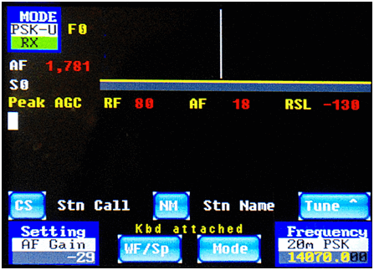

Figure 60: PSK Startup Screen

The **Mode** is shown in the upper left (PSK-U) along with the State (RX)

The **Setting** icon is displayed in the lower left corner. This shows which setting was most recently selected and is currently being controlled by the left hand encoder (AF Gain), along with its present value (-29).

The **Frequency** is shown on the lower right corner (14.070MHz) and the tuning step is 100 Hz (because the 2 least-significant digits of the frequency display are “grayed out”. It also shows the alphanumeric tag associated with the frequency preset, in this case, 20m PSK. Remember that this is no longer just a label, the Frequency Manager preset button now controls the mode associated with the frequency on each preset button.

There are two on-screen buttons that are unique to PSK operation, namely the **CS** button (callsign of the station you are working or attempting to work) and **NM** (name of the operator that you are working or attempting to work). Since these values could easily change 6 times if you make a half-dozen PSK QSO's in a row, these buttons are programmed right on the PSK Operational Screen (here) instead of being buried in a **Settings** sub-menu. When you tap on these buttons, you are given the opportunity to edit a tag called **<StnCS>** (Station CallSign) or **<StnNM>** (Station Name) respectively.

Figure 61, below, shows the entry of a callsign, VE4MA, using the on-screen **CS** button. Remember, this is the callsign of the station you are working, not your own callsign.

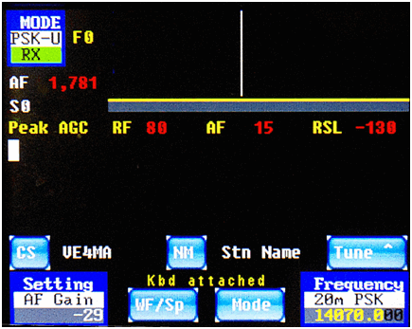

Figure 61: PSK CS (callsign) Editing Screen

Pressing the **NM** button allows you to enter the name of the station you are working. In this example, we are working Barry, VE4MA, as shown in Figure 62, below.

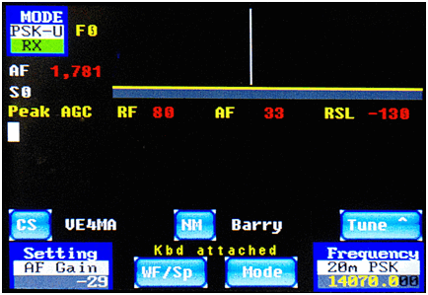

Figure 62: PSK NM (name) Editing Screen

The next on-screen button to take note of on the PSK operational screen is the **Tune** button. This is a toggle, and it shows the current tuning state right on the button. Touch the button, so it changes from **Tune ^** in the previous figures, to say **Tune v** instead**.** which means that the right-hand rotary encoder is set to tune the main VFO. Rotate the right-hand rotary encoder and change the main frequency from the current value of 14070.0 KHz (in Figure 62, above) to a value of 14071.0 KHz (in Figure 63, below).

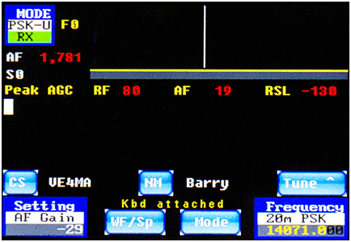

Figure 63: PSK - VFO Tuned Up to 14071 KHz

Now tap the button so the label changes from **Tune v** to **Tune ^**, and rotate the right-hand rotary encoder counter-clockwise. In this manner, you can re-tune the center of the audio passband with the NCO (Numerically-Controlled Oscillator) from the prior value of 1,781 Hz (Figure 63, above) to a new value of 945 Hz (Figure 64, below).

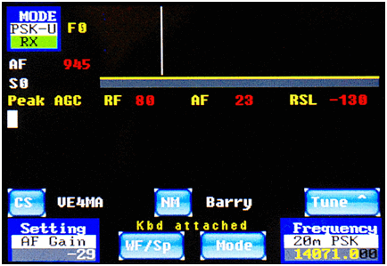

Figure 64: PSK - NCO Tuned Down to 945 Hz

When we covered the CW operational screen, we were already introduced to the **WF/Sp** and **Mode** buttons. If you tap the **WF/Sp** button now, the screen will change from what is shown in Figure 64, above, to something like what is shown in Figure 65, below. The spectrum display looks a bit bland right now because there is almost no RF activity detected. With a better antenna and better band conditions, the spectrum display would be much more interesting.

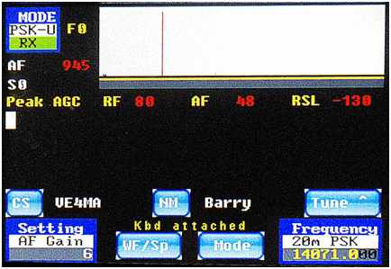

Figure 65: PSK – FFT Switched to Spectrum Display

Since we already spent a fair bit of space talking about the keyboard functions for PSK operation, let's see them in action now. Take these examples with a grain of salt, because the QSO is contrived. But it gives you a taste of how the PSK user interface works.

Let's assume that you tuned around the band and saw that a station with the callsign VE4MA was active. Before you call him, use the CS and NM buttons to fill in his callsign and name. This way, when the proper function keys are pressed later on, the proper information will be sent to him. When all is set, press the keyboard **F1** function key. It will turn on the transmitter, send out a CQ and your callsign, and then turn off the transmitter. This can be seen in Figure 66 above. The picture was snapped right after the transmitter was turned off, hence it shows the system is back in receive (Rx) mode.

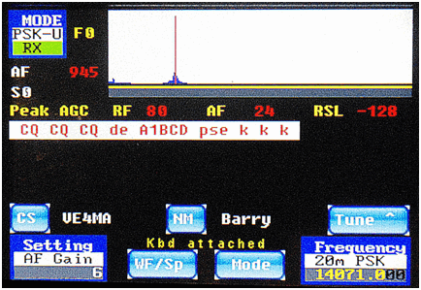

Figure 66: PSK – Starting a QSO

Let's assume that Barry replies to your call. Now you want to send him your name and QTH. To do this, press the **F10** key to turn on the transmitter, and press the keyboard **F2** key to send your information. This will cause the radio to transmit your name and QTH (as previously stored in the tags **<MyName>** and **<QTH>**). While the transmitter is on, you can also press the keyboard **F3** key to send information about your rig. The screen will then resemble Figure 67, below.

To send information about your antenna, press the keyboard **F10** key again to turn on the transmitter, and then press the keyboard **F4** key to send the antenna information as stored in the tag **<Ant>**. The screen will then resemble Figure 68, below.

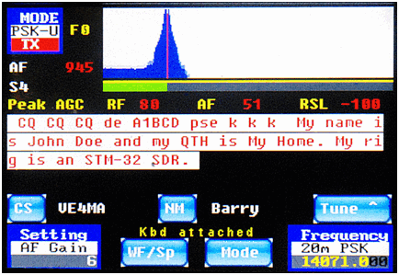

Figure 67: PSK – Continuing a QSO

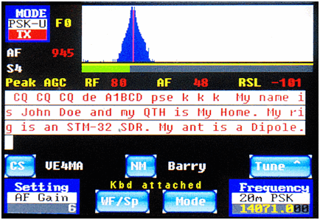

Figure 68: PSK – Continuing a QSO

You can then press the keyboard **F10** key to listen for Barry's reply to you. You might then counter his reply by pressing the keyboard **F10** key again to start transmitting, and then pressing keyboard **F5** to send a BTU (Back To You) message in which you confirm to Barry that you copied his callsign and name correctly. And then, of course, you press the keyboard **F10** key one more time to turn off the transmitter. The resultant screen might look a little bit like Figure 69, below.

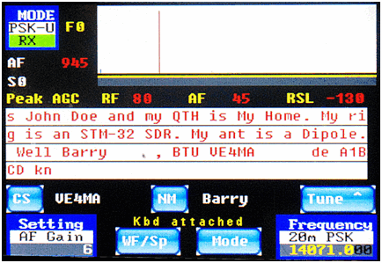

Figure 69: PSK – Continuing a QSO

Finally, when you are ready to terminate the QSO, you can press the keyboard **F10** key to turn on the transmitter, press the keyboard **F6** key to send a thank you and your good wishes, and press the keyboard **F10** key one last time to turn off the transmitter. The resultant screen will resemble Figure 70, below.

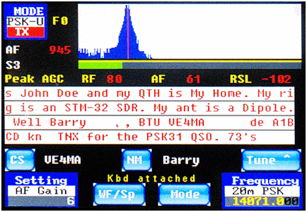

Figure 70: PSK – Completing a QSO

Of course, it should be noted that you are not restricted to sending only canned phrases from the keyboard function keys **F1** through **F6**, and **F12**. At any time in the QSO, you can press the keyboard **F10** key to turn on the transmitter, and then type any message you wish on the keyboard directly. And then press the keyboard **F10** key to turn off the transmitter. The function keys are simply shortcuts to frequently used phrases. And wouldn't you rather type your callsign once into a **Settings | <Tags>** screen instead of typing it a hundred times for a hundred QSO's? The shortcuts are now all under your full control. Program them as you wish, use them (or don't use them) as you wish.

# AGC Modes Explained

For those people interested in how our AGC (Automatic Gain Control) modes work, here is an explanation from Charley W5BAA, who is the author of our AGC and many other portions of our firmware.

The AGC control scheme controls two amplifiers in our CODEC (Coder/Decoder). One is the PGA (Programmable Gain Amplifier), and the second is the DAC (Digital to Analog converter).  
  
There are 4 modes of AGC operation: Peak (Mode 0), Digi (Mode 1), SSB (Mode 2), and Off (Mode 3).

## Mode 0

In the Peak mode, the PGA's AGC is controlled by the Peak (highest) magnitude found in any of the FFT bins over the entire audio spectrum from 300 - 3500 Hz. Also, the DAC's AGC is controlled by the Peak magnitude in this mode.

## Mode 1

In the Digi mode, the PGA's AGC is controlled by summing only the magnitude bins from 2 pixels below the cursor through 2 pixels above the cursor. However, the DAC's AGC is controlled by the Peak magnitude, as described above for Mode 0.

## Mode 2

In the SSB mode, the PGA's AGC is controlled by summing the magnitude bins over the entire audio spectrum from 300 - 3500 Hz. The DAC's AGC is controlled by the Peak magnitude, as described above.

## Mode 3

In the Off mode, the PGA's AGC is controlled by the RX_RF value which was set manually, and the DAC's AGC is controlled by the RX_AF value, which was also set manually, on the Settings screens.

There are two AGC values shown on the PSK Page: RF and AF. RF is the raw value being sent by the AGC to the CODEC to control the PGA gain stage. It can range between 0 and 80, which represents a range of gain from 0 to 40 dB. AF is the raw value being sent by the AGC to the codec to control the DAC gain stage. It can range from -127 to +48, which represents a range of gain from -65 dB to +24 dB.  
  
When receiving signals, you will see these two values decrease with stronger signals and increase with weaker signals.

# PSK Cheat Sheet

## F1: Call CQ

## F2: Send Your Name and QTH

## F3: Send your Rig information

## F4: Send your Antenna information

## F5: Confirm Called Station Name and Callsign, and send Back to You (BTU)

## F6: Send Thank You and Best Wishes (73's)

## F7: (Changes to USB mode)

## F8: (Changes to LSB mode)

## F9: (Changes to CW mode)

## F10: Toggles Transmitter Between Receive and Transmit Mode

## F11: Clear Transmit Buffer

## F12: _________________________________________________________________

# Radio Setup

Perform **Rx Amp** and **Rx Phase** balancing to maximize opposite sideband suppression. The quick overview of this is as follows: Provide a strong signal to the receiver. Switch to the opposite sideband and adjust **Rx Amp** and **Rx Phase** to minimize the rejected sideband. The **Rx Amp** and **Rx Phase** controls do interact somewhat, so several adjustments will be required. Once you are satisfied with the unwanted sideband rejection, simply exiting from the **Settings | Advanced** screen will ensure that you store the values in EEPROM for subsequent operation.

Don’t forget to adjust the **Mic Bias** to allow for proper operation of the type of microphone that you are using. Set to 1 to provide a mic bias voltage (needed for an electret microphone element), or to 0 for no bias (non-electret microphones). If your microphone requires a bias voltage and you have this option set to zero, the typical symptom will be that there is no apparent response to the microphone no matter how loudly you speak into it!

Of course, you will need to adjust the **Mic Gain**, the **Tx Level** and the **Side Tone** level for best operation of your system.

# Appendix – Tags, Functions, Buttons, and Keyboard.

**Tags** are essentially named variables. The names of 12 of the 14 variables can be changed, as can the text strings stored within any of them. The present version of the firmware supports a maximum of 14 tags, although only 7 of them are currently in use, leaving the other 7 available for your creativity to put into use.

**Functions**, on the other hand, are hard-coded in the firmware to perform a specific action. You cannot re-name them or change the action that they perform. What you are able to do is assign them to be invoked by either one or more on-screen buttons (which you can rename) or to the 12 function keys on the top row of an attached keyboard.

There are presently 10 on-screen programmable buttons. Four of them are located on the SSB operational screens, four are located on the CW operational screens, and two of them are located on the PSK screens. You can edit the label shown on the face of the SSB and CW buttons, and the actions caused by tapping the on-screen button. By “actions” we mean one or more functions that are executed when the on-screen button is tapped. These 10 on-screen buttons are only programmed using one or more functions.

A standard keyboard has 12 programmable function keys, labeled **F1** through **F12**. You are able to program the action(s) performed by each of those function keys. These function keys can be assigned combinations of literal text strings, tag names, and/or functions. When a function key is pressed, any literal strings are transmitted if you are in PSK Transmit mode. Any **tags** cause their corresponding string *value* to be transmitted under the same circumstances. Any **functions** in the definition are executed.

## Tags

By default, the 14 tags are defined as follows:

* **<StnCS>** station callsign (the station you are trying to work)
* **<StnNM>** station name (the station you are trying to work)
* **<myName>** your name
* **<myCall>** your Amateur Radio callsign
* **<QTH>** your operating location (city, state/province, grid square, etc.)
* **<Rig>** description of your rig, *e.g.*, **IQ32**
* **<Ant>** description of your antenna, *e.g.*, **Dipole**
* **<T6>** unused, empty string
* **<T7>** unused, empty string
* **<T8>** unused, empty string
* **<T9>** unused, empty string
* **<T10>**  unused, empty string
* **<T11>** unused, empty string
* **<T12>** unused, empty string

Remember, any of the tags *except* ***<StnCS>*** *and* ***<StnNM>*** can be renamed to something more meaningful to you if you choose to do so. And, of course, the string values associated with them can also be programmed by you from the **Settings | Tags** menu screen (except **<StnCS>** and **<StnNM>,** which are set on the PSK operational screens).

## Functions

**Functions** are actions that occur when invoked by an on-screen button or a keyboard function key. You have no control over their names or their actions, except by changing the source code of the firmware and re-compiling it. You either use them or don't.

The built-in functions that are available for you to call are as follows:

* **<NoFilt>** Audio Filter 0, *i.e.*, No audio filter, pass 0 – 4000 Hz
* **<Filt1>** Toggle between Audio Filter 0 and Audio Filter 1, 300-3300 Hz
* **<Filt2>** Toggle between Audio Filter 0 and Audio Filter 2, 300-2700 Hz
* **<Filt3>** Toggle between Audio Filter 0 and Audio Filter 3, 300-1300 Hz
* **<Filt4>** Toggle between Audio Filter 0 and Audio Filter 4, 400-700 Hz
* **<Filt5>** Toggle between Audio Filter 0 and Audio Filter 5, 500-600 Hz
* **<NxFil2>** Toggles among Audio Filter 0 and 2 others (F0, F1, F2)
* **<NxFil3>** Toggles among Audio Filter 0 and 3 others (F0, F1, F2, F3)
* **<NxFil4>** Toggles among Audio Filter 0 and 4 others (F0, F1, F2, F3, F4)
* **<NxFil5>** Toggles among Audio Filter 0 and 5 others (F0, F1, F2, F3, F4, F5)
* **<Rx>** Change to Receive Mode
* **<Tx>** Change to Transmit Mode
* **<Tx/Rx>** Toggle, Change to Rx if in Tx mode, Change to Tx if in Rx mode
* **<Spect>** Change to FFT Spectrum view
* **<Wfall>** Change to FFT WaterFall view
* **<WF/Sp>** Change to Waterfall if in Spectrum, or to Spectrum if in Waterfall
* **<USB>** Change to Upper SideBand Mode
* **<LSB>** Change to Lower SideBand Mode
* **<CW>** Change to CW (Continuous Wave or Morse Code) Mode
* **<CWR>** Change to Reverse CW Mode
* **<PSK-U>** Change to PSK31 in Upper Sideband Mode
* **<PSK-L>** Change to PSK31 in Lower Sideband Mode
* **<Clear>** Clear the PSK Transmit Buffer
* **<Freq>###** Tune to Frequency ### Khz
* **<NxMode>** Cycles to Next Mode, USB→LSB→CW→PSK→USB etc.
* **<pkAGC>** Set AGC to Peak Operation
* **<DigAGC>** Set AGC to Digital Operation
* **<SSBAGC>** Set AGC to SSB Operation
* **<OffAGC>** Set AGC to Off
* **<NxAGC>** Cycle through AGC modes Peak→Digital→SSB→Off→Peak etc.

## Default On-Screen Button Functions

### SSB Operational Screens Buttons

1. **<NxAGC>**
2. **<Tx/Rx>**
3. **<NxFilt2>**
4. **<NxMode><NoFilt>**

### CW Operational Screens Buttons

1. **<NxAGC>**
2. **<WF/Sp>**
3. **<NxFilt5>**
4. **<NxMode><NoFilt>**

### PSK Operational Screens Buttons **

1. **<WF/Sp>**
2. **<NxMode><NoFilt>**
3. [CS] = **edit** **<StnCS>**
4. [NM] = **edit** **<StnNM>**

**Note: The on-screen buttons for the PSK Operational Screens are treated differently than the buttons on the SSB and CW Operational Screens. There are no provisions for the user to modify the label or the action of the first two buttons listed above. This is probably an accidental omission from the **Settings | Screeen Fn** screen. The second two buttons are different because not only are their labels not alterable, they do not invoke any named functions. They always/only initiate the editing of two named tags, one for the name of the station being called or worked, and the other for the callsign of the station being called or worked. Since these two tags could require changes numerous times during a run of PSK QSO's, it makes sense for them to be treated specially, changeable right from the PSK operational screen instead of requiring the operator to invoke the **Settings | <Tags>** screen,

## Keyboard Function Keys

There are 12 function keys on the top row of a standard keyboard, and you can configure how the IQ32 firmware reacts when these keys are pressed. By default, keys **F1** through **F6** and **F11** are devoted to simplifying PSK31 QSO's, keys **F7** through **F9** are devoted to quickly changing among the modes of operation (SSB, CW, and PSK), **F10** is used as a software PTT key, and **F12** is unassigned. These function keys are programmed with combinations of literal strings (to be transmitted during a PSK QSO), tags (whose corresponding string values are to be transmitted during a PSK QSO), and functions (which are executed). Here are the default associations, any or all of which can be easily changed by the user via the **Settings | Keyboard Fn** menu:

* F1: **<Tx>**CQ CQ CQ de **<myCall>** pse k k k **<Rx>**
* F2: My name is **<myName>** and my QTH is **<QTH>**.
* F3: My rig is an **<Rig>**.
* F4: My ant is a **<Ant>**.
* F5: Well, **<stnNM>**, BTU **<stnCS>** de **<myCall>** kn **<Rx>**
* F6: THX for the PSK31 QSO. 73's
* F7: **<USB>**
* F8: **<LSB>**
* F9: **<CW>**
* F10: **<Tx/Rx>**
* F11: **<Clear>**
* F12: (not assigned at the present time, available for your use)